AZURE VIRTUAL MACHINE, FUNCTIONS AND APP SERVICES
Agenda
- Virtual Machine
- Virtual Machine Scale Set
- Azure Container Instances
- Functions in Azure
- Azure App Services
Virtual Machine:
Azure Virtual Machines (VMs) provide scalable, on-demand compute resources in the cloud, allowing users to run applications just like they would on a physical server, but without the complexities of managing hardware. As part of Infrastructure-as-a-Service (IaaS) in Microsoft Azure, VMs offer flexibility in terms of operating systems, configurations, and resource allocation. Users can choose from various VM sizes tailored to different workloads, including general-purpose computing, high-performance computing (HPC), AI/ML training, and database hosting.
Key Features:
- Multiple OS options (Windows, Linux).
- Full control over configuration & management.
- Scalable compute with different VM sizes.
- Pay-as-you-go pricing model.
- Integration with Azure services (Storage, Networking, Security).
Use Cases of Azure Virtual Machines (VMs):
- Hosting Applications & Databases – VMs are used to deploy web applications, APIs, and databases like SQL Server, MySQL, and PostgreSQL without managing physical servers. They ensure scalability and high availability for business applications.
- Running Development & Testing Environments – Developers use VMs to create isolated environments for coding, testing, and debugging applications. They allow quick setup of different OS versions and configurations without affecting production.
- High-Performance Computing (HPC) – VMs with powerful CPUs and GPUs enable tasks like big data processing, AI/ML training, and scientific simulations that require high computational power.
- Disaster Recovery & Backup – VMs help maintain business continuity by replicating workloads across different Azure regions, ensuring quick recovery in case of failures.
Creating and Managing Azure VMs:
Steps to Create an Azure VM (Portal):
Step 1: Sign in to Azure Portal → Go to Virtual Machines → Click Create.
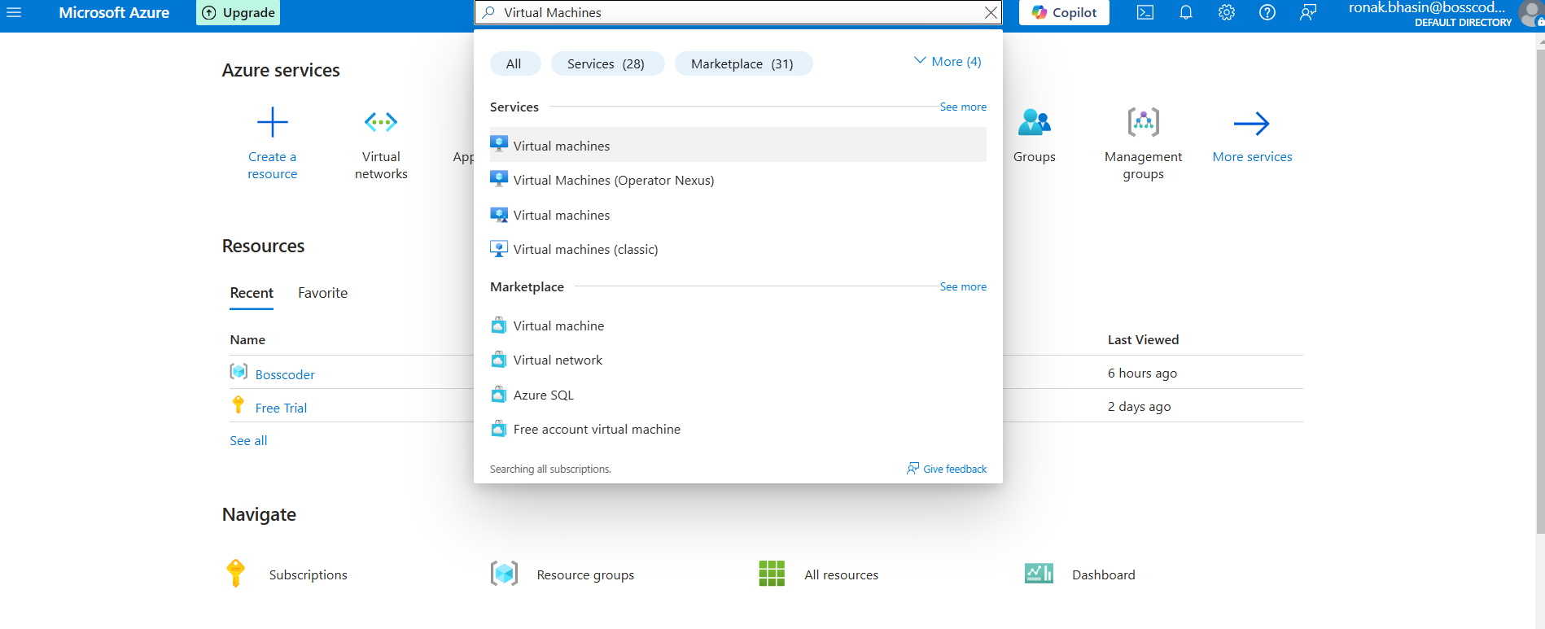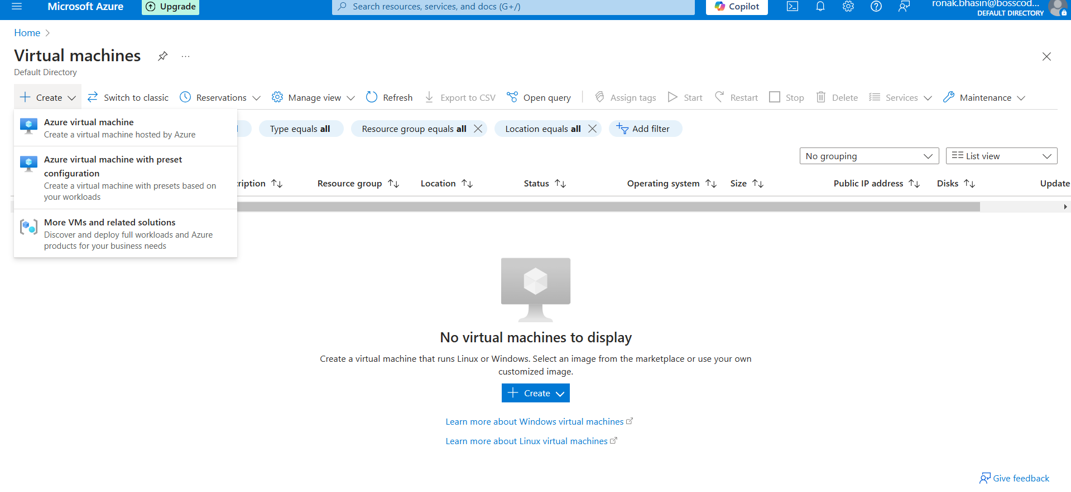
Step 2: Now, enter the details and set all the details related to Disks, Networking, Management, Monitoring and then go to Review and Create and then finally Create.
Step 2: Now, enter the details and set all the details related to Disks, Networking, Management, Monitoring and then go to Review and Create and then finally Create.
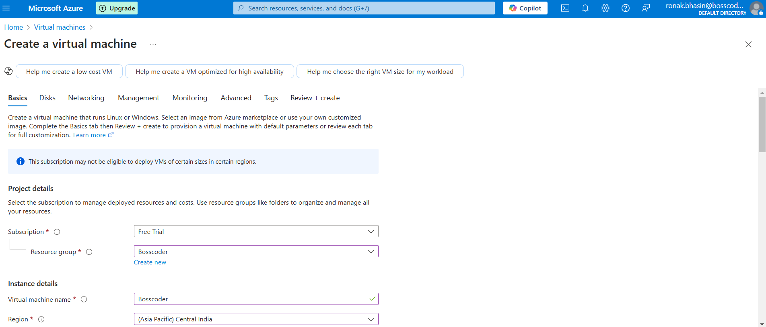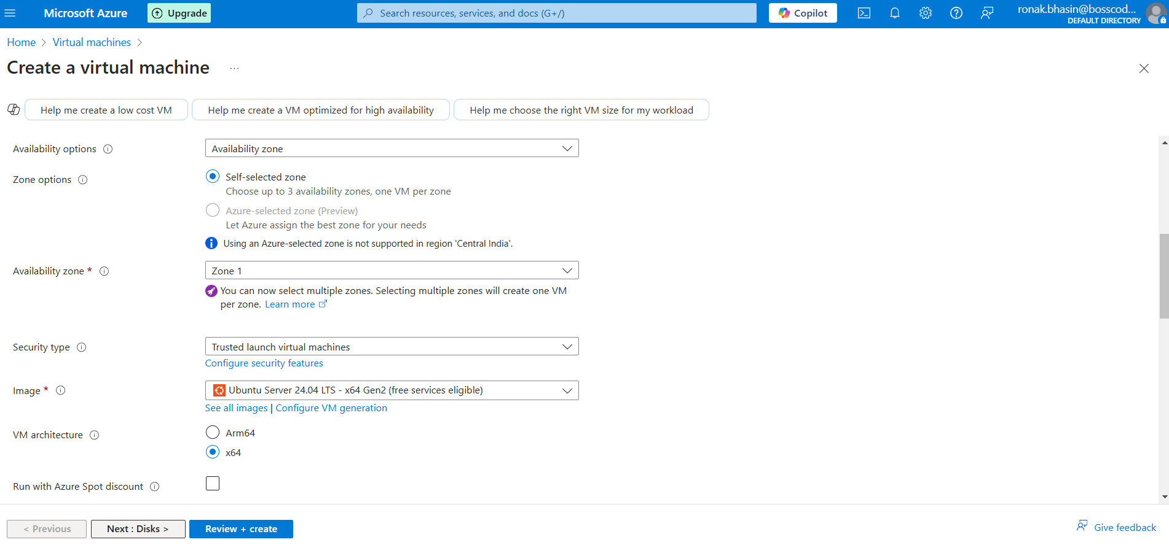
Step 3: Then, finally Create Virtual Machine.
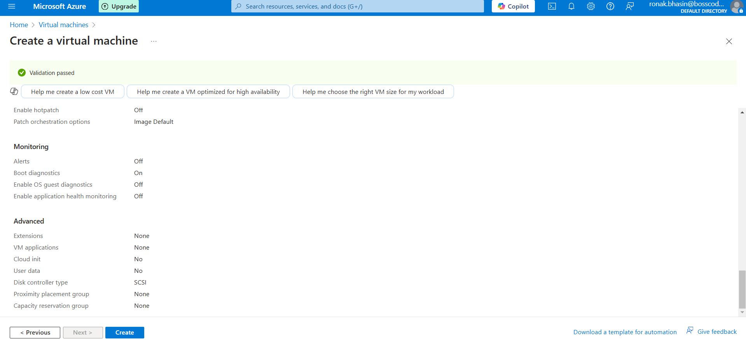
Step 4: Now, it will be deployed and will be listed in the virtual Machines list section.
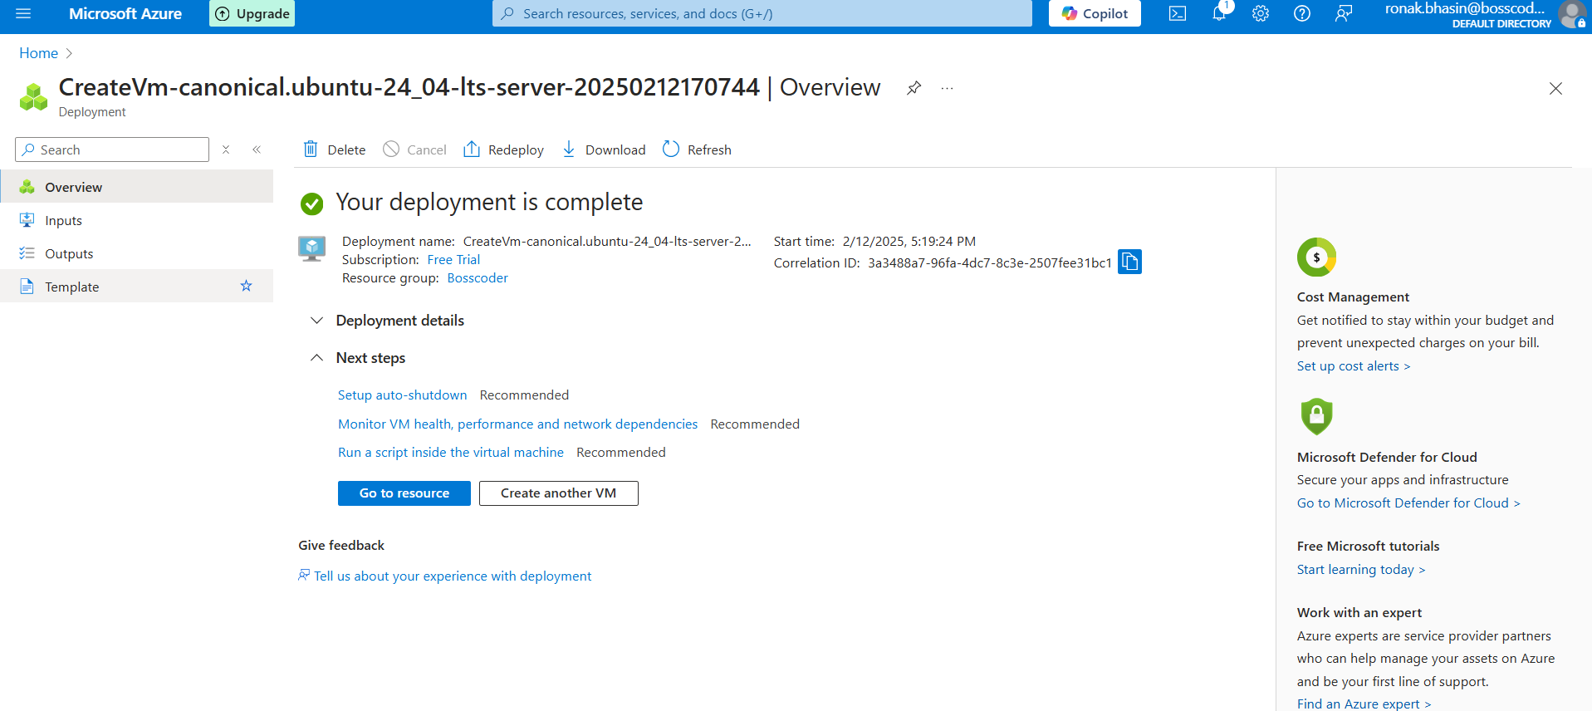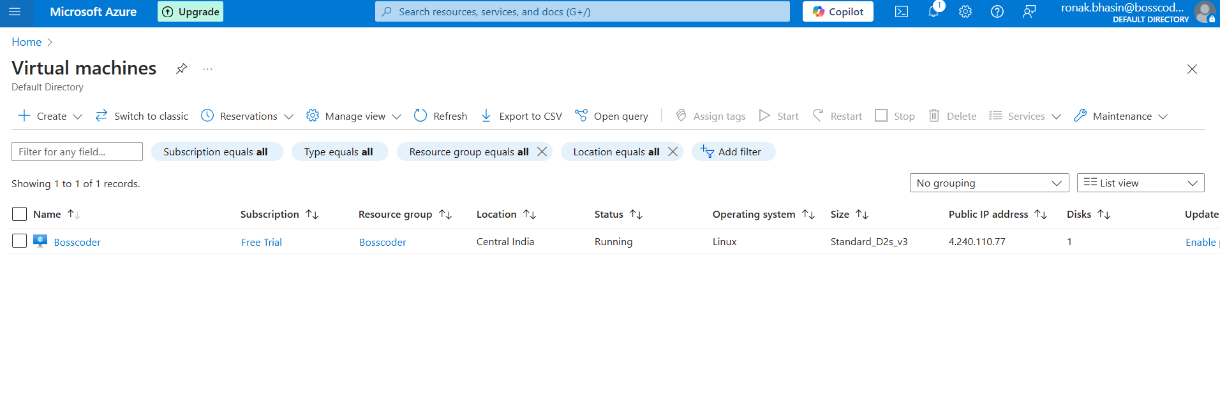
Managing Azure VMs:
- Start, Stop, Restart, Delete VMs via Azure Portal.
You can perform these operations by opening the Virtual Machine.
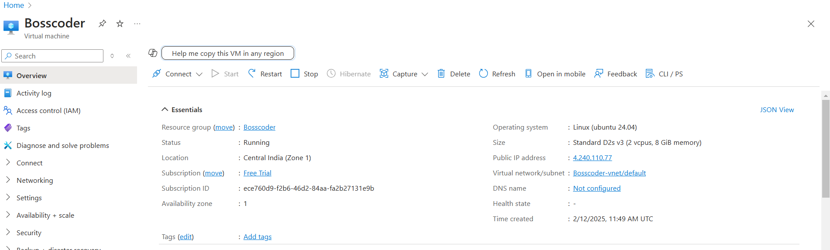
- Resize VMs dynamically to adjust performance needs.
By the Size option in the left Menu, you can change the Size of VM.
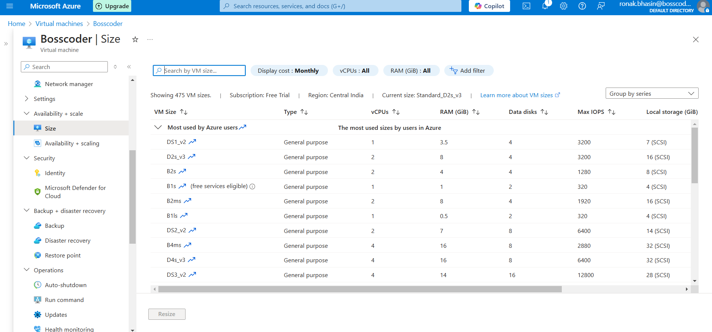
- Attach/Detach Disks to expand storage.
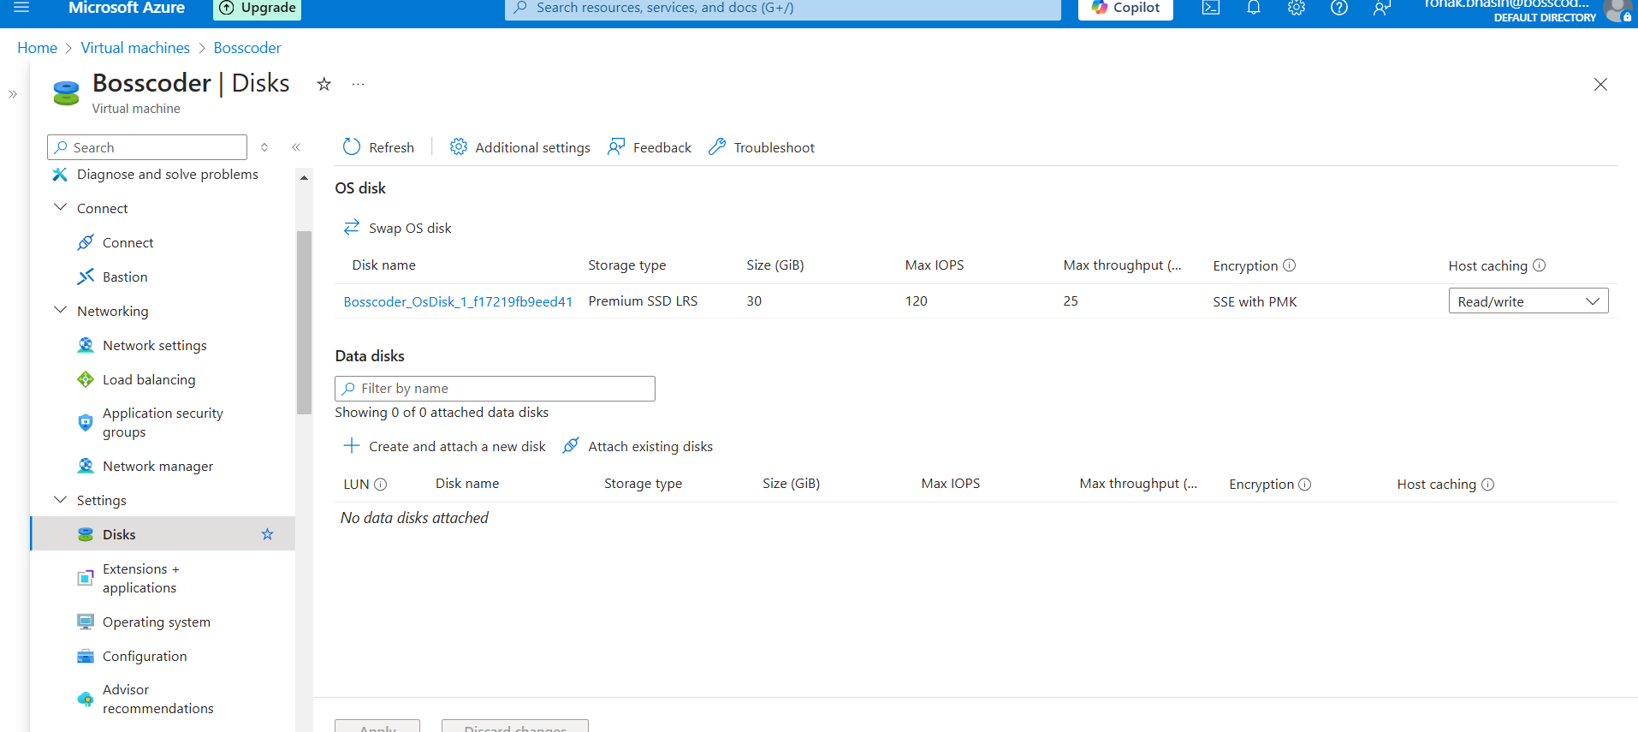
- Enable Monitoring with Azure Monitor & Log Analytics.
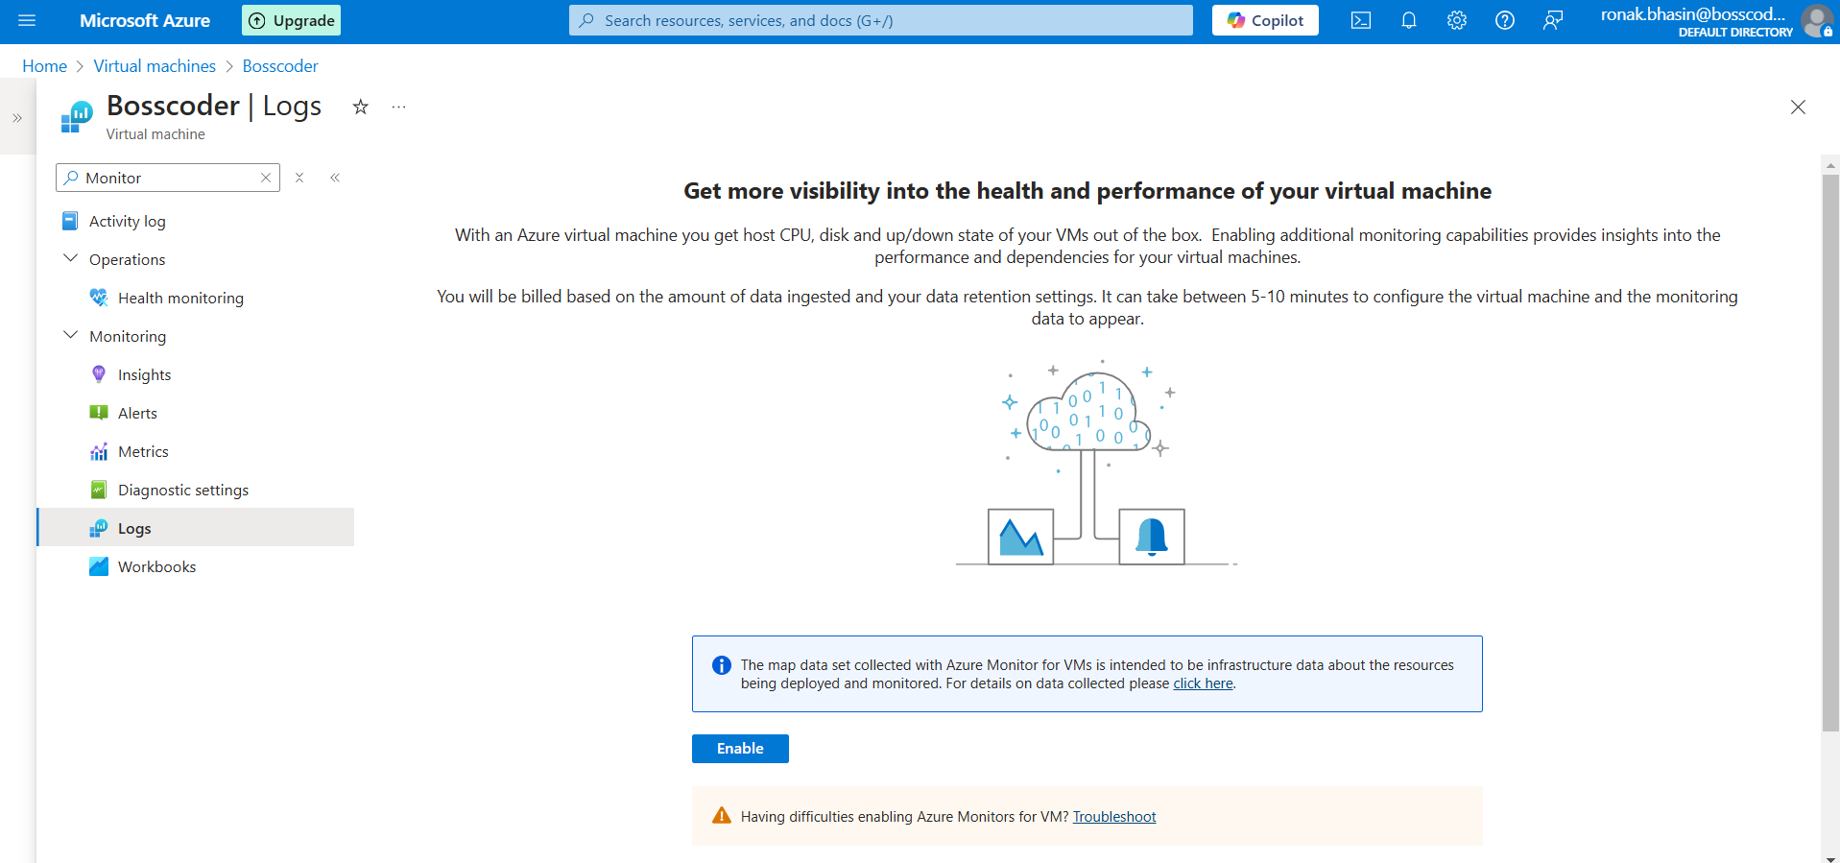
Virtual Machine Scale Set:
A Virtual Machine Scale Set (VMSS) in Microsoft Azure is a service that allows you to deploy and manage a group of identical virtual machines (VMs) with auto-scaling capabilities. It helps in maintaining application availability and automatically adjusting the number of VMs based on demand.
Key Features of Azure Virtual Machine Scale Sets (VMSS):
- Automatic Scaling – Can scale in or out based on CPU usage, memory, or custom metrics.
- Load Balancing – Works with Azure Load Balancer and Azure Application Gateway to distribute traffic.
- High Availability – Spreads VMs across availability zones or fault domains for redundancy.
- Integration with Azure Services – Works with Azure Monitor, Azure Automation, and Autoscale.
- Custom Images & Marketplace Images – Can use custom VM images or Azure Marketplace images.
- Uniform & Flexible Scaling – Supports Uniform Mode (identical VMs) and Flexible Mode (diverse VM configurations).
- Automatic OS Upgrades – Keeps instances up to date with minimal downtime.
Steps to Create Virtual Machine Scale Sets:
Step 1: Go to Azure portal, search for VMSS and then go for it and click on Create.
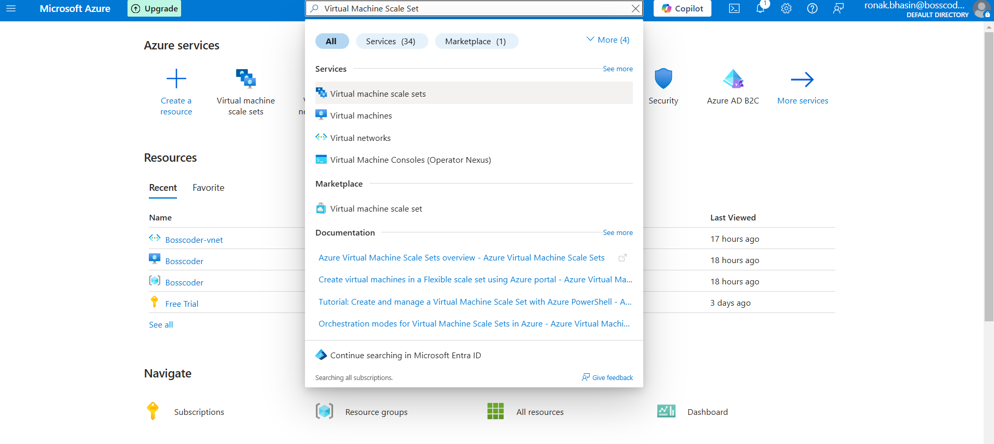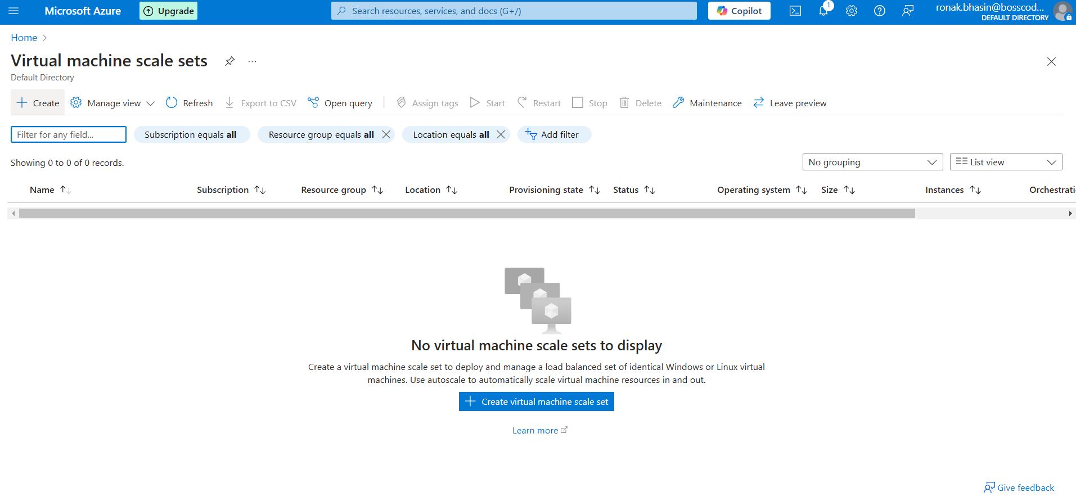
Step 2: Then, you can create VMSS by entering all the details required and then review and create the VMSS.
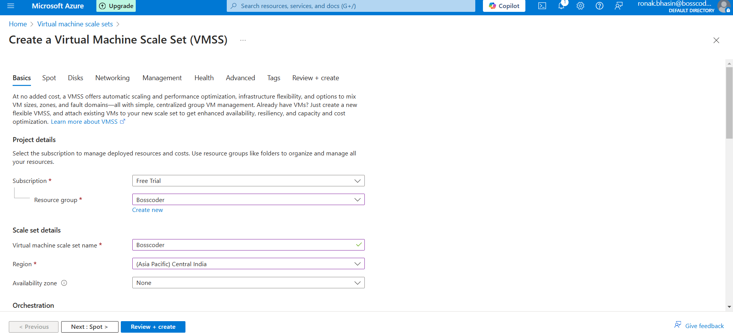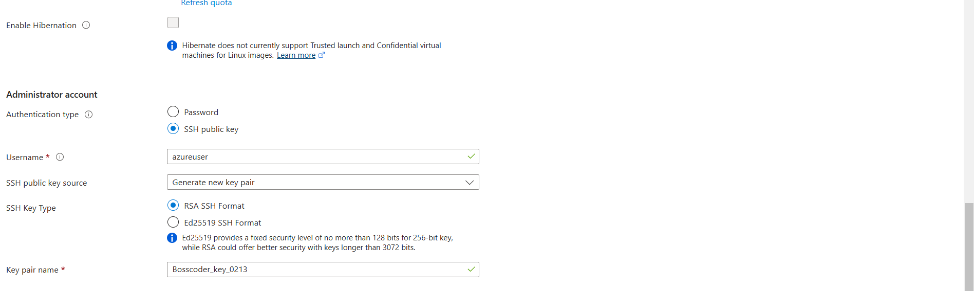
Azure Container Instances(ACI):
Azure Container Instances (ACI) is a serverless container service that allows you to run Docker containers without managing virtual machines or Kubernetes clusters. It provides a quick, scalable, and cost-effective way to run containerized applications.
Features of ACI:
- Serverless – No need to manage infrastructure.
- Fast Deployment – Containers start within seconds.
- Supports Linux & Windows Containers – Run any OS-based container.
- Scalability – Automatically scales based on demand.
- Networking – Can be integrated with Azure Virtual Networks (VNet).
- Persistent Storage – Uses Azure File Share for data storage.
- Security – Containers run in an isolated Hyper-V environment.
Deployment of ACI:
Step 1: Go to Azure Portal → Create a Resource → Search "Container Instances".
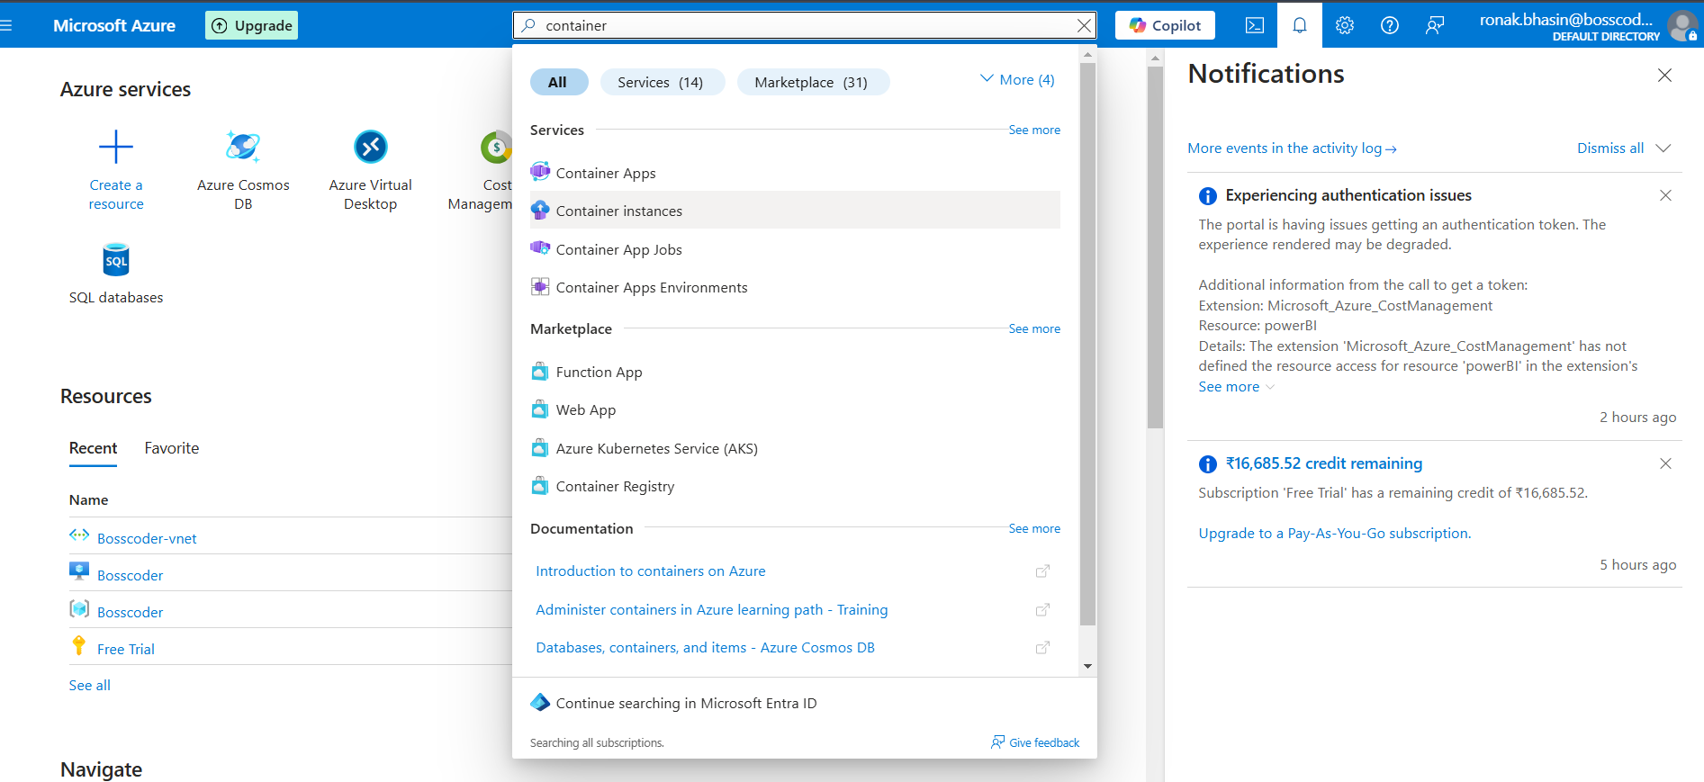
Step 2: Configure:
- Container Name
- Image Source (Docker Hub, Azure Container Registry, etc.)
- CPU & Memory
- Networking & Ports
Step 2: Configure:
- Container Name
- Image Source (Docker Hub, Azure Container Registry, etc.)
- CPU & Memory
- Networking & Ports
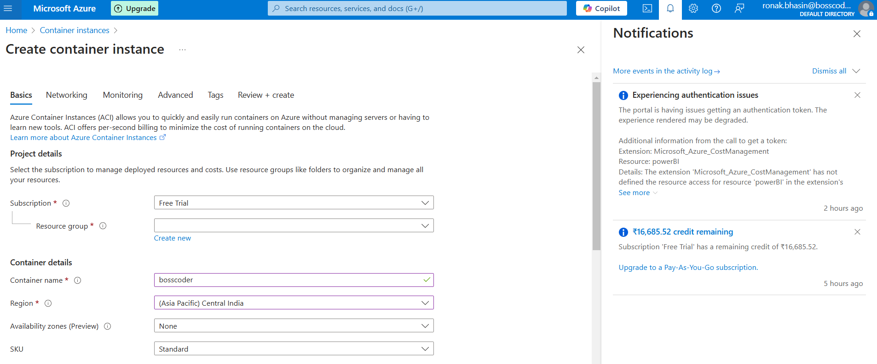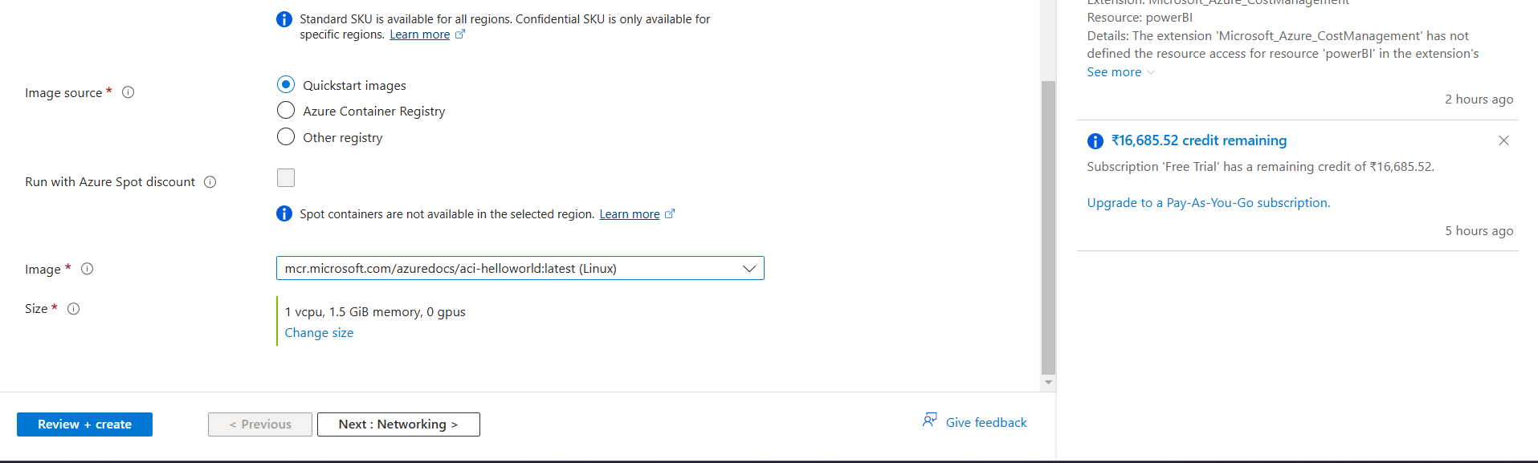
Step 3: Now, in advanced section you can enter some docker commands as well
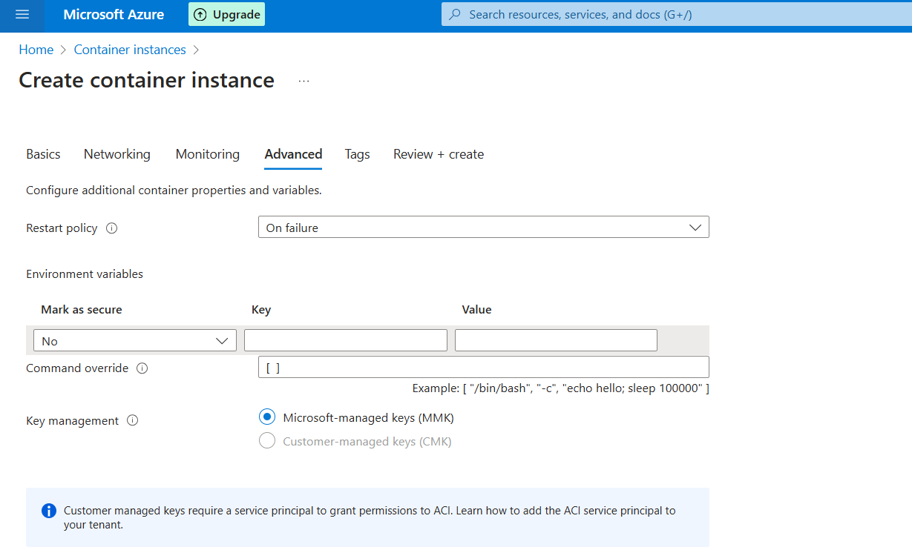
Step 4: Now, go to the Review and Create section, then a validation test will run, after successful validation, you can finally Create.
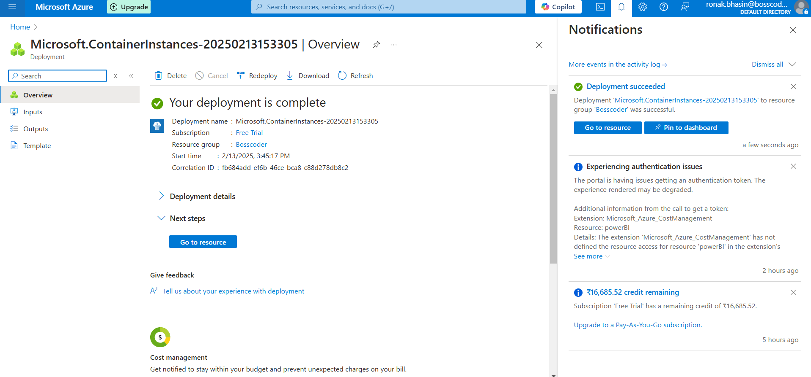
Step 5: Now, you can go to Containers and see that it is in running state and in logs state, you can watch the port number, then go to Overview and copy the IP address and open it on a new browser along with Port Number.
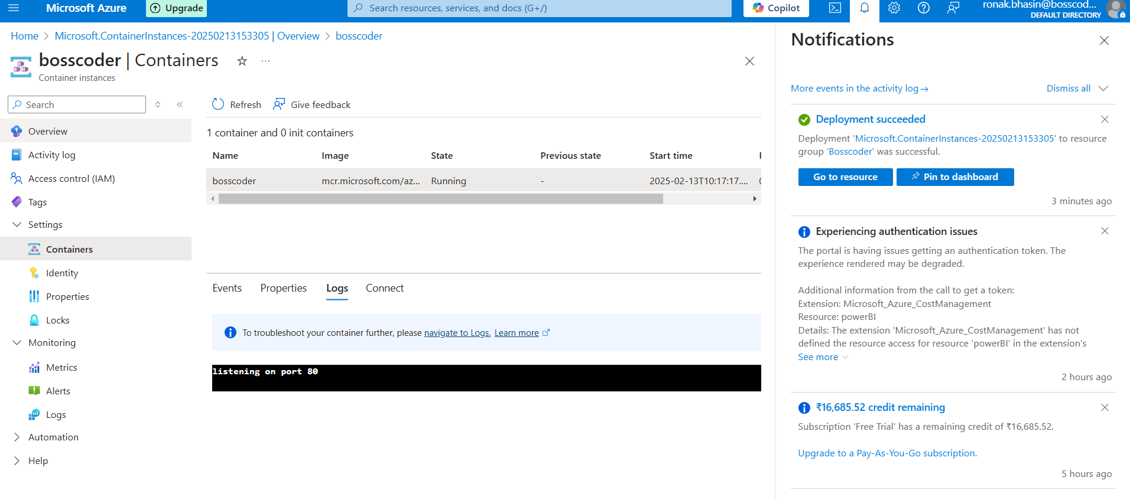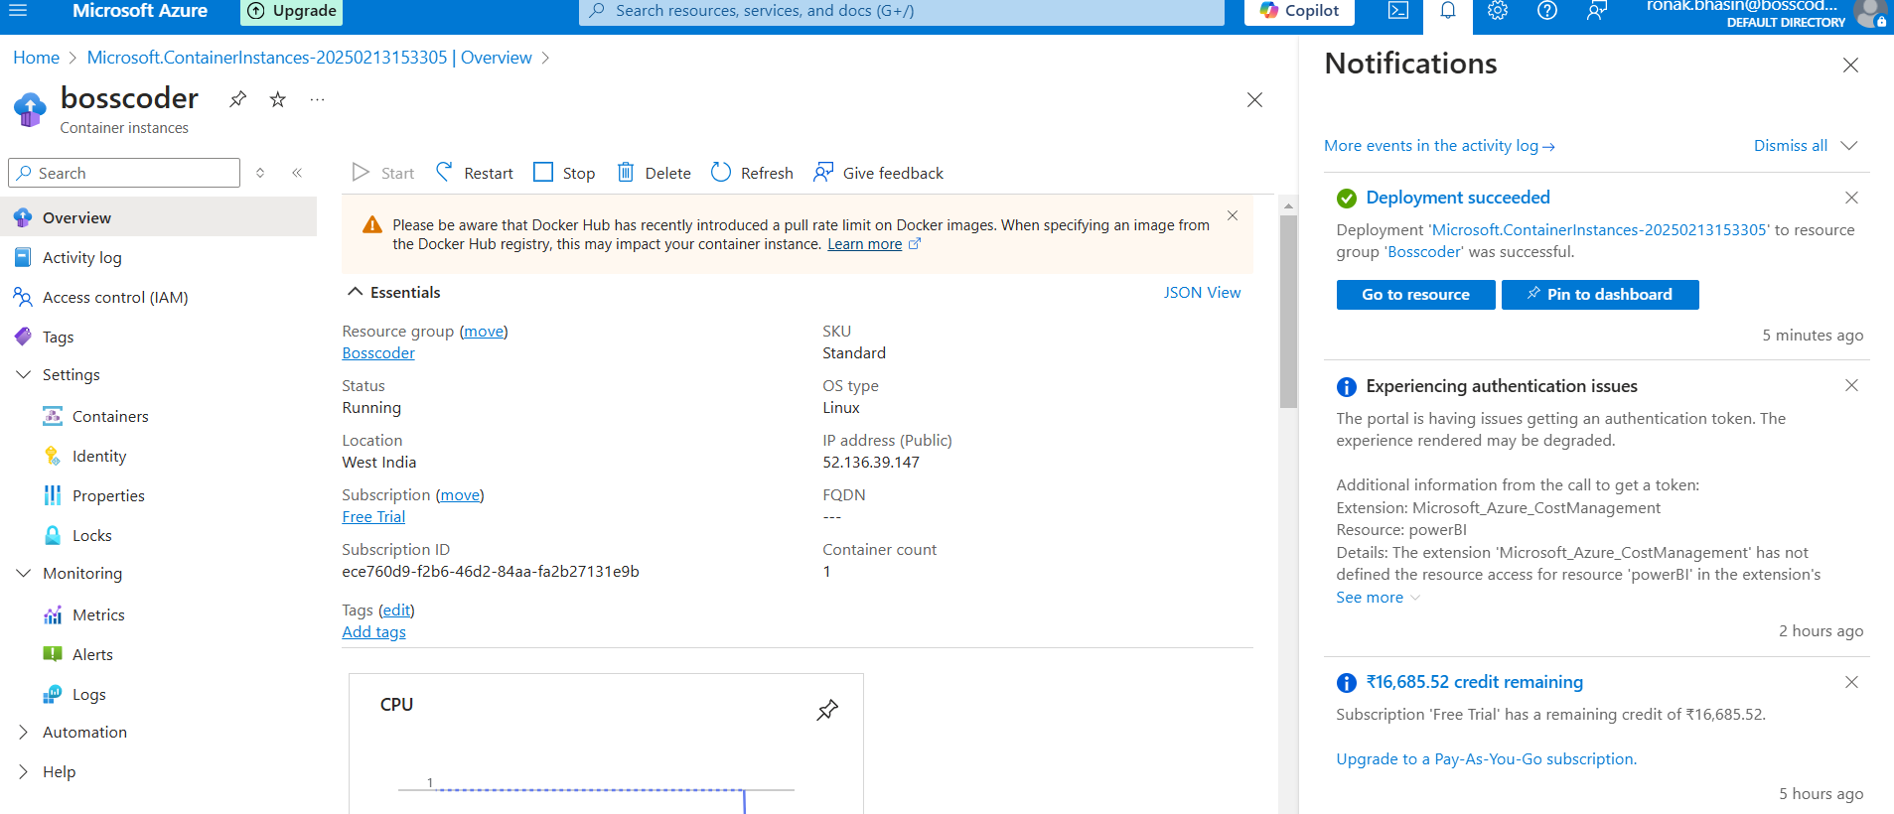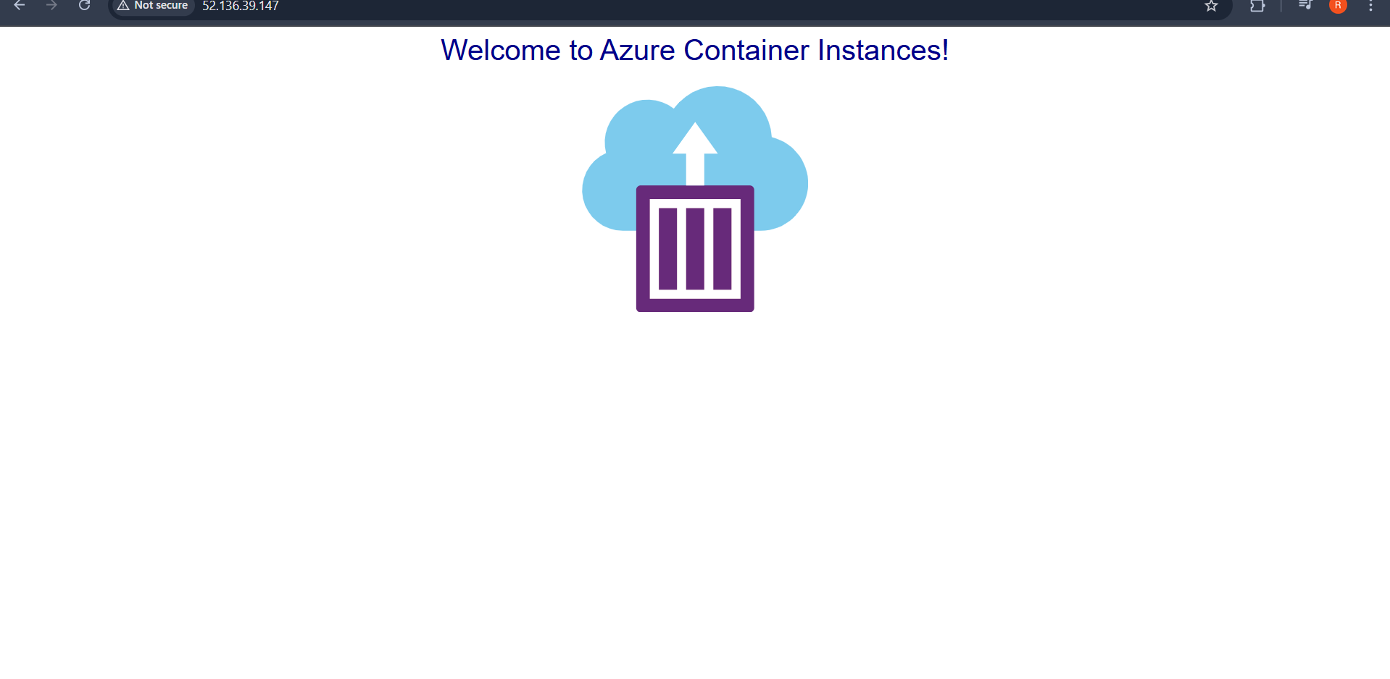
Functions in Azure:
Azure Functions is a serverless compute service that enables users to run event-driven applications without provisioning or managing servers. It helps developers focus on writing code while Azure takes care of the infrastructure, scaling, and execution.
Key Benefits:
- Serverless execution (no need to manage infrastructure).
- Event-driven (triggers execution based on defined events).
- Auto-scaling (scales automatically as per demand).
- Pay-as-you-go pricing (only pay for the execution time).
- Supports multiple programming languages (C#, Python, Java, JavaScript, etc.).
Architecture of Azure Functions:
Azure Functions works on a trigger-based execution model, where functions execute in response to specific events.
Main Components:
- Triggers – Defines how a function is invoked (e.g., HTTP requests, queue messages, database changes).
- Bindings – Provides a way to connect functions with other Azure services (input/output).
- Execution Environment – Functions run in an isolated environment with managed dependencies.
Types of Azure Function Triggers:
Azure Functions can be triggered by various Azure services or external events.
Trigger Type | Description
HTTP Trigger | Executes when an HTTP request is received.
Timer Trigger | Runs on a schedule (like CRON jobs).
Blob Trigger | Fires when a file is added/modified in Azure Blob Storage.
Queue Trigger | Runs when a message is added to an Azure Storage Queue.
Event Grid Trigger | Responds to Azure Event Grid notifications.
Event Hub Trigger | Processes messages from Azure Event Hub (for real-time processing).
Cosmos DB Trigger | Runs when there is a change in an Azure Cosmos DB collection.
Service Bus Trigger | Triggers when a message is added to Azure Service Bus.
Steps to Create Functions:
Step 1: Go to the Azure portal and search for Functions App.
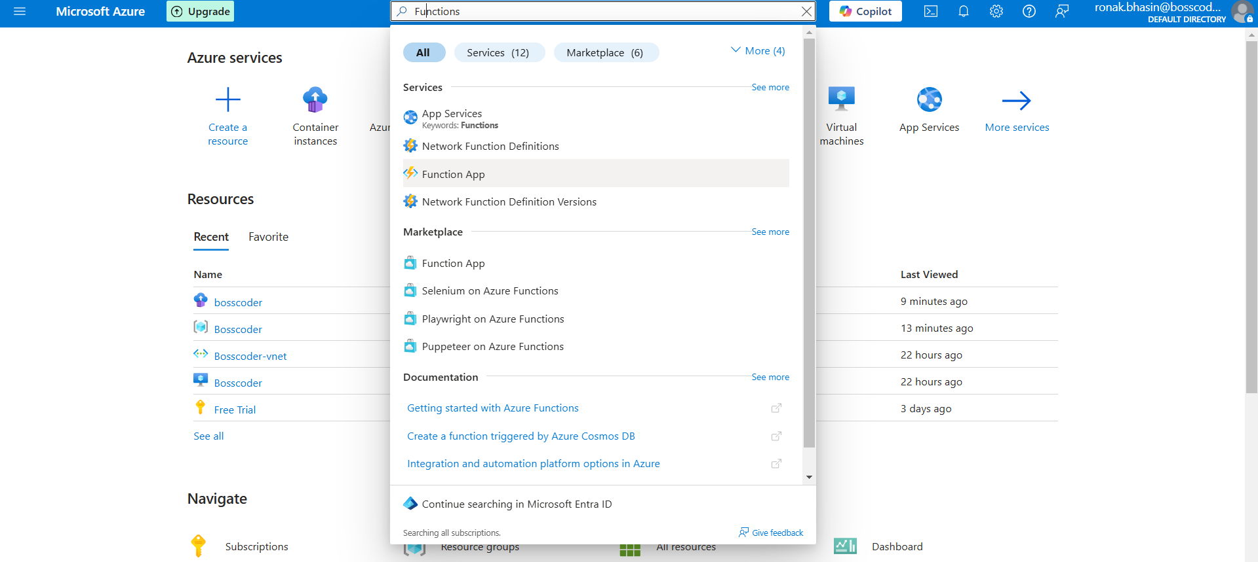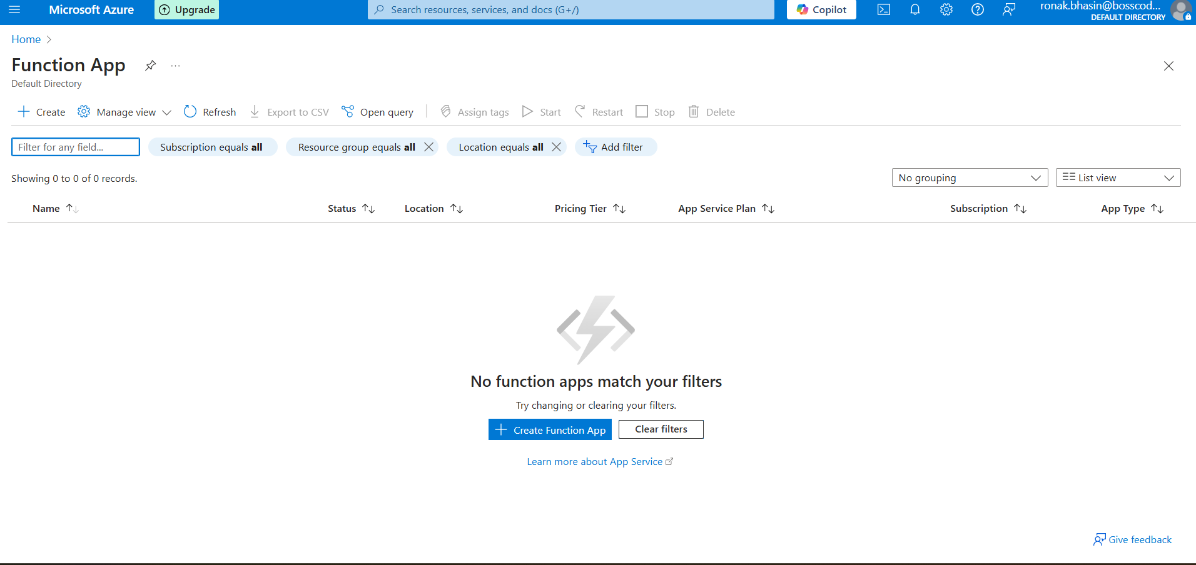
Step 2: Now, click on Create and enter details
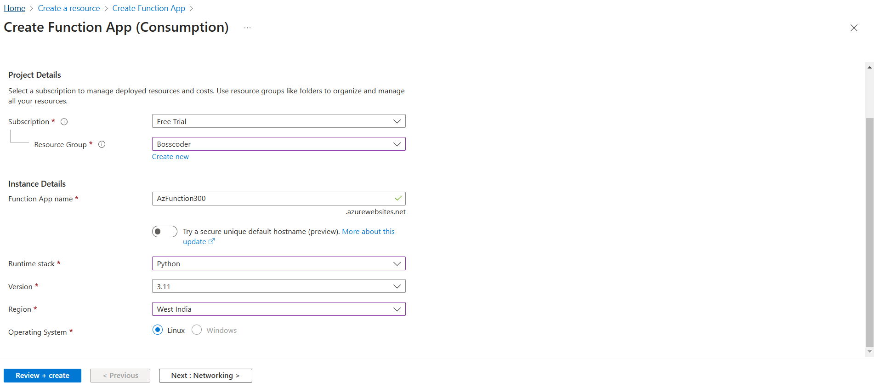
Step 3: Now, set Public Access in the Networking section, then set Monitoring, Deployment and then finally Create, then it will be deployed.
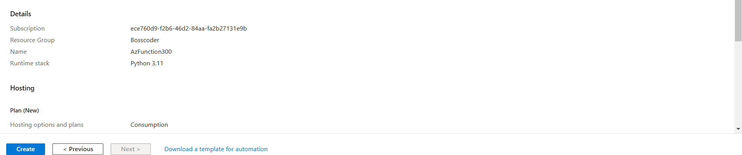
Step 4: Now, open this and select Functions.
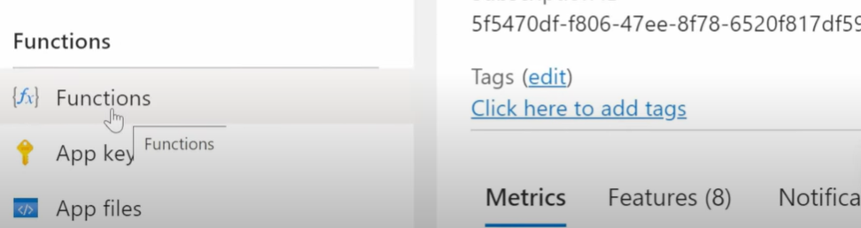
Step 5: Now, go to Create FUnction and select the Environment, set the Trigger and Create.
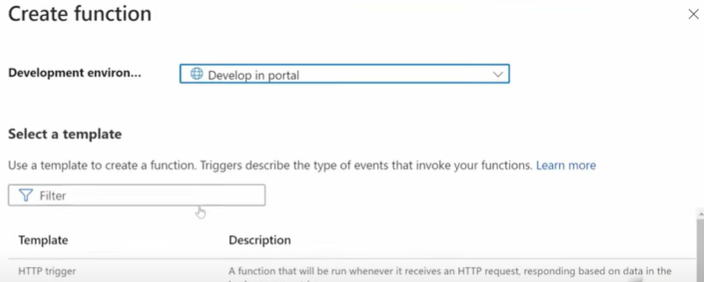
Step 6: Now, go the Developer option and select Code+Test option
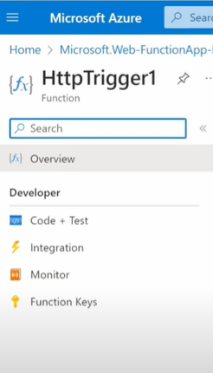
Step 7: Then, you can go to Integration and set as per you.
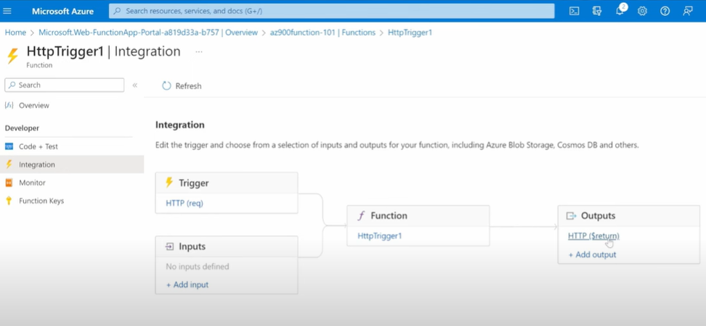
Azure App Services:
Azure App Services is a fully managed platform for building, deploying, and scaling web applications, RESTful APIs, and mobile backends. It eliminates the need for managing infrastructure, enabling developers to focus on application development.
Key Benefits:
- Supports multiple programming languages (.NET, Java, Python, PHP, Node.js, etc.).
- Fully managed environment (handles security, scaling, and load balancing).
- Continuous integration and deployment (CI/CD) support.
- Built-in security & authentication using Azure Active Directory (AAD).
- Auto-scaling & high availability.
Types of Azure App Services:
App Services provides four primary services:
1. Web Apps
- Used to host web applications and websites.
- Azure supports ASP.NET, Java, Python, PHP, Node.js, and more.
- Integrates with GitHub, Azure DevOps, and other CI/CD tools.
2. API Apps
- Used for hosting and managing RESTful APIs.
- Built-in API connectors for Azure Logic Apps.
- Supports API security with OAuth and Azure AD.
3. Mobile Apps
- Used for developing mobile backends with features like offline sync.
- Supports push notifications and authentication.
- Connects to databases like Azure SQL, Cosmos DB, and MySQL.
4. Logic Apps
- Used for workflow automation and integrating cloud services.
- Supports low-code/no-code development.
- Automates processes across multiple cloud services (e.g., Azure, Office 365, Salesforce).
Steps for Web App:
Step 1: Go to Azure Web portal and search for App Services
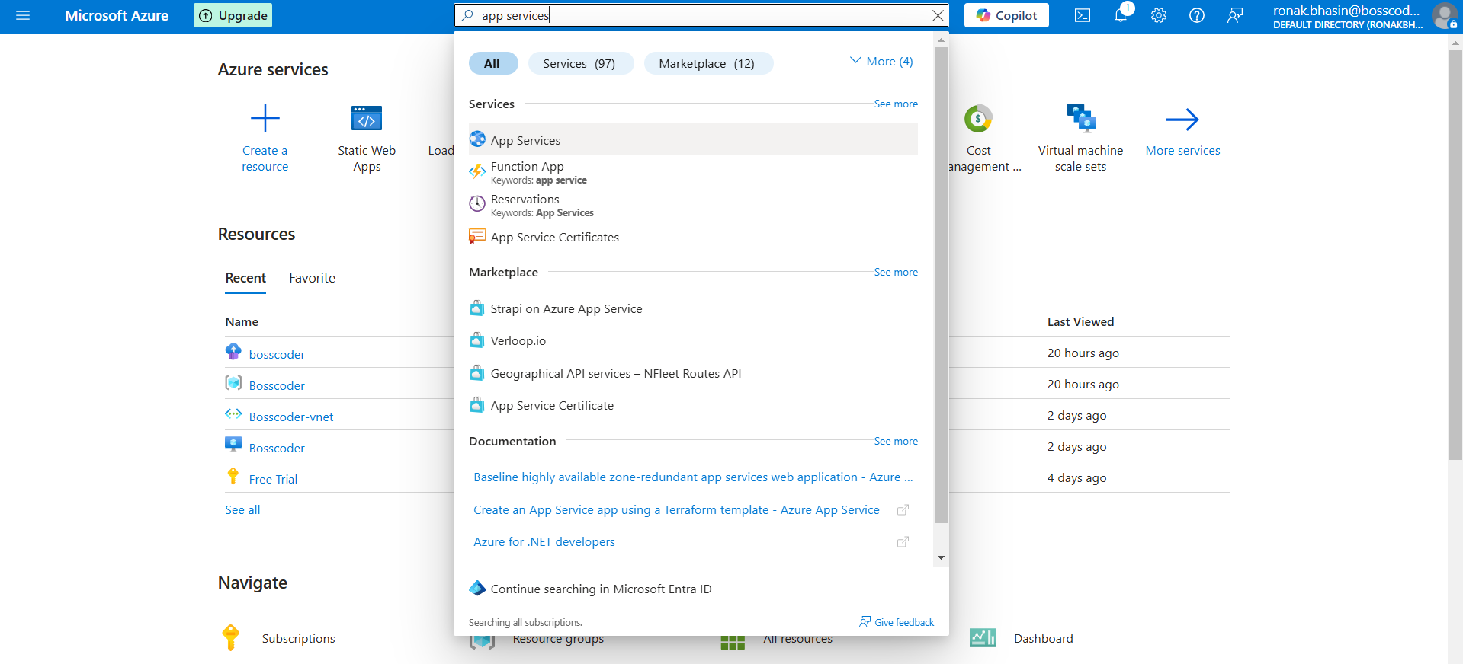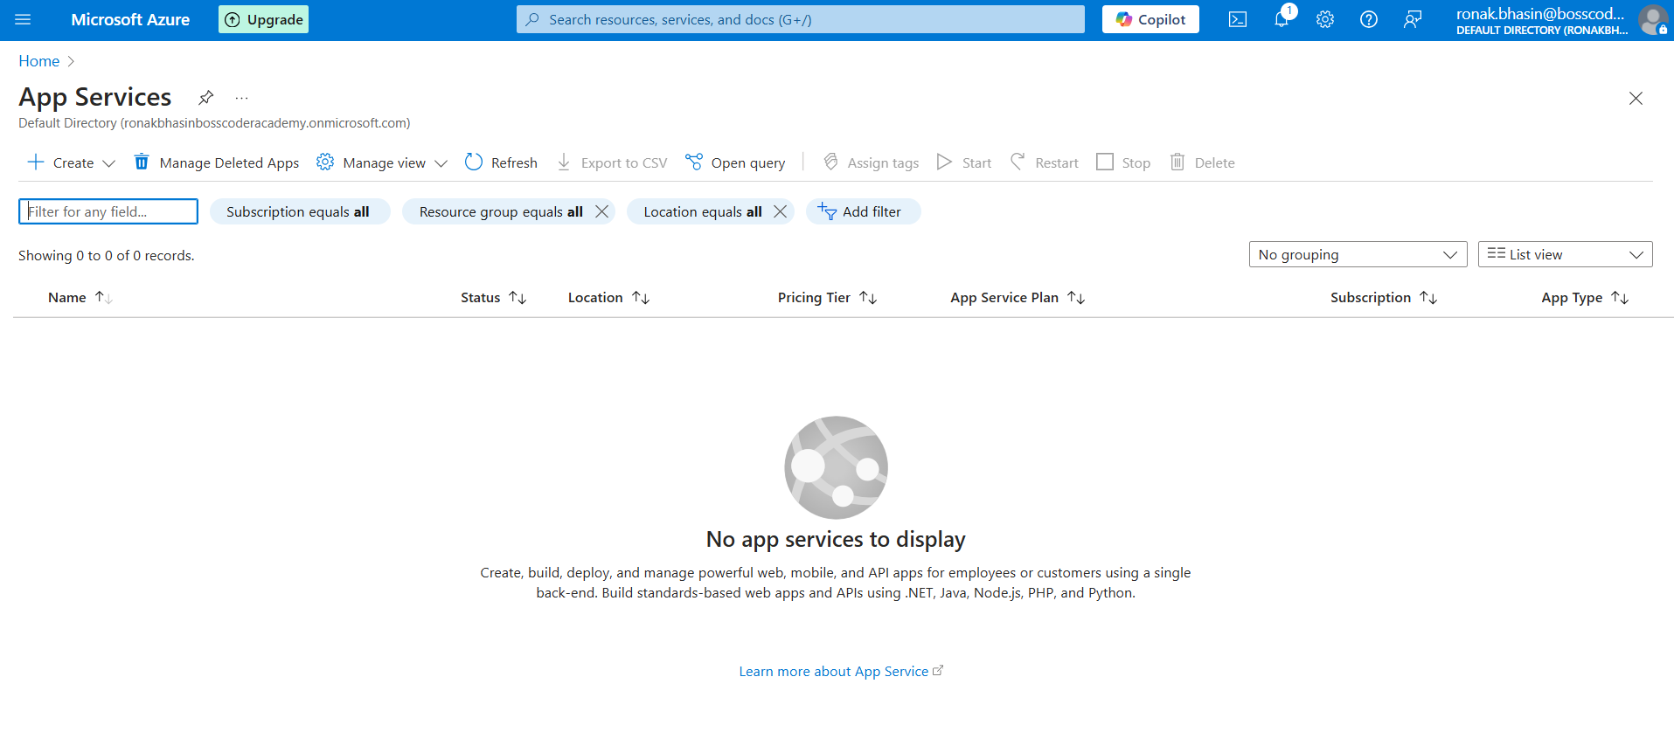
Step 2: Now, go to Create and select Web App.
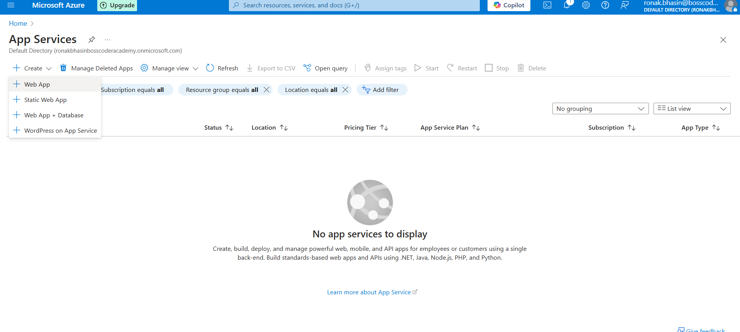
Step 3: Now, enter the details
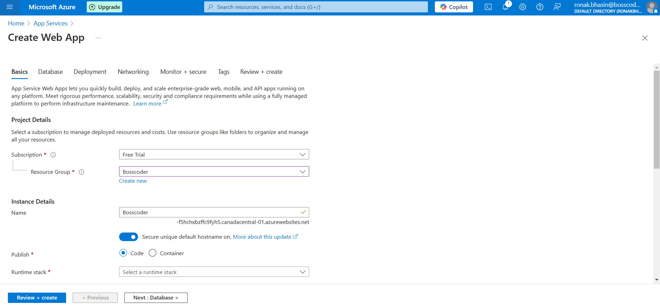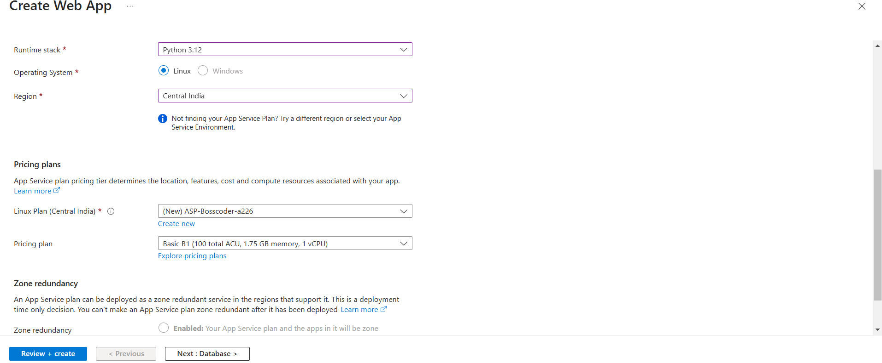
Step 4: Then, set up the deployment.
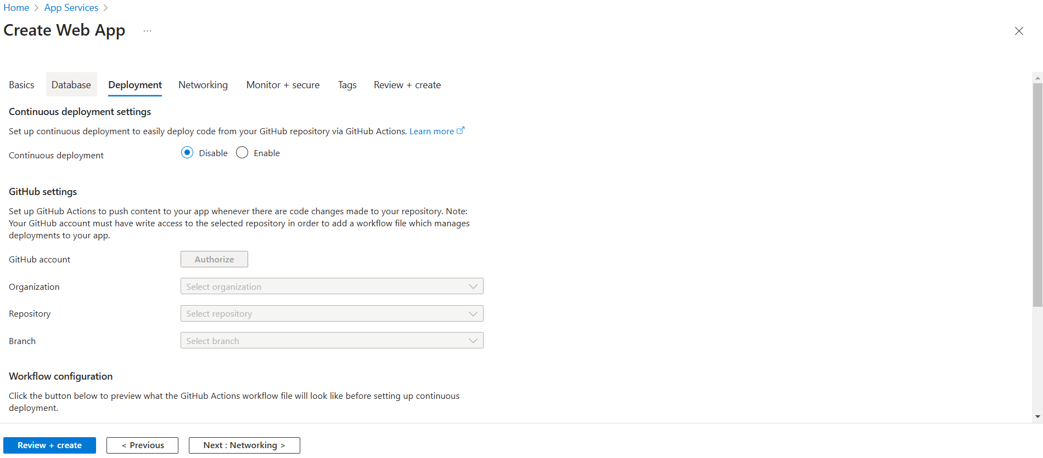
Step 5: Now, click on Review and Create, the Web App is created.
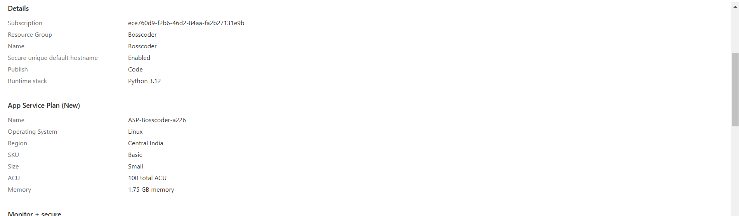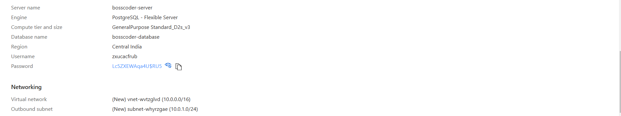
Step 6: Now, you can also connect VNet by enabling the virtual Network Integration feature.

